MobileTestingScenario_runTestScenario_Instance3_06-Apr-2016_07-52-19_AM_Staging_Page_Navigation.png

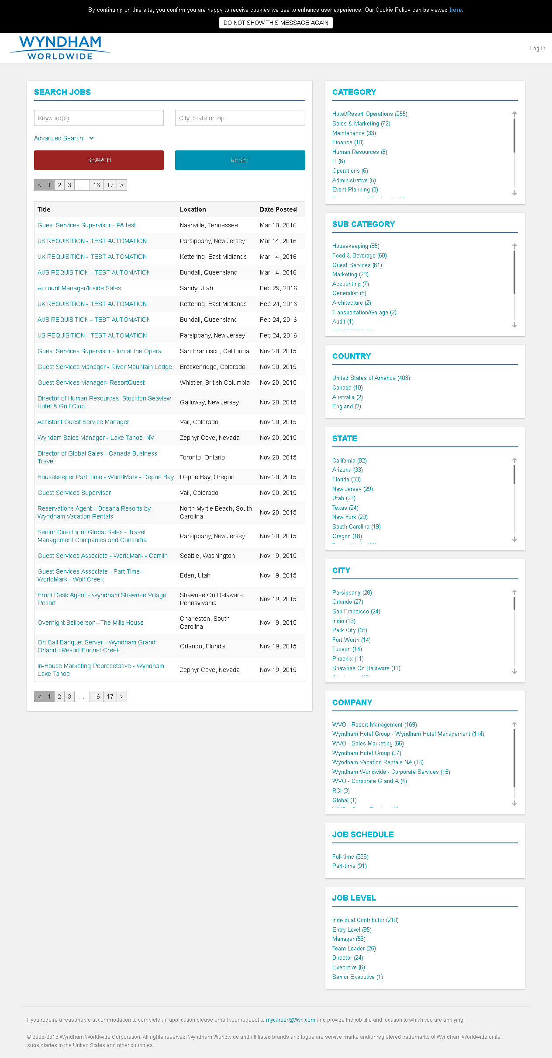

MobileTestingScenario_runTestScenario_Instance3_06-Apr-2016_07-52-59_AM_Create_Account.png

